Dear 7th grade Parents and Guardians, November 19, 2008

Everywhere around the world hunger is a persistent problem that requires everyone’s help. In order to increase awareness and donations, a competition called “Canstruction” was created in North America. Teams of engineers, architects, and students gather to create sculptures made of canned foods. The competition has been held for 11 years in 76 cities around the continent. After the sculptures have been judged, all the food is donated to food shelters. In 2007, over 2 million pounds of food was donated. Look at the official Canstruction competition and winners at: http://www.canstruction.org/images/downloads/2007_national_winners.pdf

Here in Guatemala hunger is prominent:
- 44.2% of the population does not have proper nutrition.
- Hunger is most acute in Chiquimula department in the west, particularly the municipalities of Camotán, Jocotán and Olopa.

- Roque reported that ''the Guatemalans who are most suffering from hunger are the indigenous peoples of the Mayan ethnicity known as Chortí.''
- According to the United Nations Development Program's ''Human Development in Guatemala 2000'', approximately 57 percent of the country's 12 million inhabitants are poor. Civil society groups, however, say the true percentage is probably higher than 80 percent.

7th grade students will be participating in their own Canstruction competition. For this project they will need to save as many cans as possible over the holidays in December. When we return to class in January each group of four students will create a sculpture using the cans. Students are encouraged to gather as many full cans of food as possible, however, I can not be require you or students to purchase canned food so they will be allowed to use empty cans as well. At the end of the competition the full cans of food will be donated to Casa Alianza, an organization that provides shelter and education to children, teens, and adults. There are many ways to get full cans of food such as asking for donations or asking for them as Christmas gifts. All can should be brought to school the first class day we return after December. 7B & 7C: Tuesday, January 6th 7A & 7D: Wednesday, January 7th

During Canstruction, students will have to use problem solving to make their structure stable. They will be encouraged to think about the color of labels and how they relate to the object. The following are the categories students will be judged:
- Favorite (Jurors overall favorite)
- Structural Ingenuity (Most difficult structure to build and keep standing)
- Best use of labels (Did the best job combining the use of color with the design)
- Best Meal (Used the most FULL and HEALTHY cans of food)
- Most Cans (Used the most full or empty cans of food in the design)
- Honorable Mention (Jurors second favorite overall)
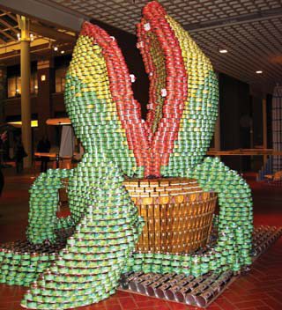
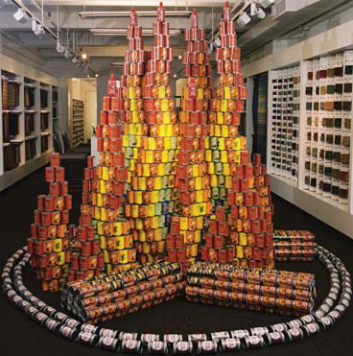
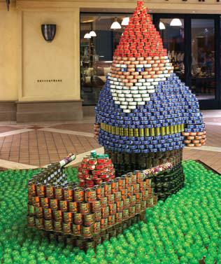

Juror’s Favorite 2007 Best Use of Labels 2007 Best Meal 2007

Thank you in advance for your support and help gathering cans at home!!!

~Lauren Karle, MS Art Teacher

